incAccounting
Bug Fixes
This document will outline the bug fixes that are currently found in the program and the recommended changes needed in order to correct these issues

1 Requirements
This section will list out the current bugs and how to test them. It will also outline the expected result, and the observed result

1.1 Login
Launch Program and login with invalid credentials

1.1.1 Expected Results
Upon logging in with invalid credentials, be given a message that the user is using invalid credentials.

1.1.2 Observed Results
Upon logging in with invalid credentials, the screen resets and text boxes are cleared

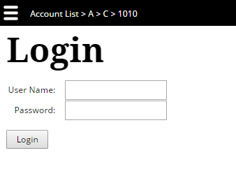
1.2 Edit Load
Upon Login in, click menu→ Click Users/Group/Computer→ Click “+”

1.2.1 Expected Results
Upon loading, the “Is Allowed” box needs to be marked by default and password date need to be defaulted to today's date.

1.2.2 Observed Results
Upon loading, “Is Allowed” box is unmarked by default. The Password Date combo boxes are left empty

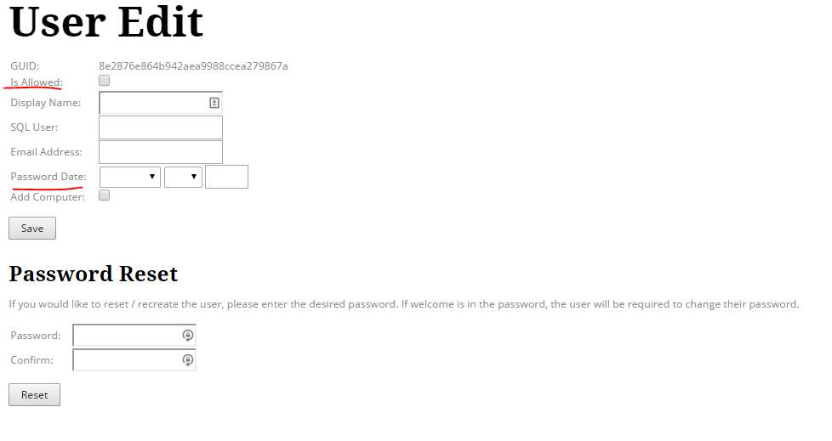
1.3 User Edit Save
Upon Login in, click menu→ Click Users→ Click “+”→Create Duplicate User/Empty User→Click Save

1.3.1 Expected Results
The program should prevent the user from creating duplicate or empty users and alert the user to fill in the specified forms accordingly.

1.3.2 Observed Results
The user is currently able to create duplicate users and users that do not have a display name/SQL User.
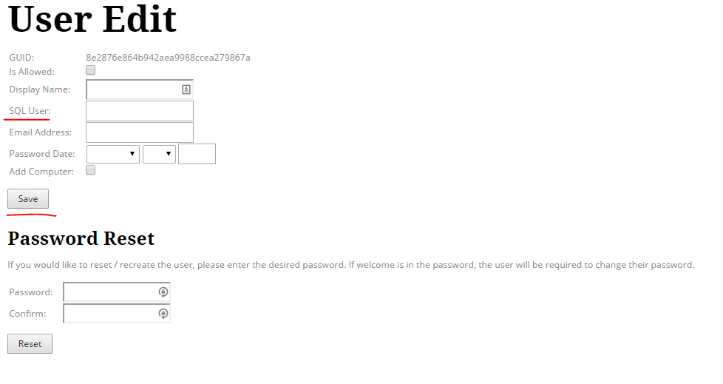

1.4 User Edit Save Sql User
Upon Login in, click menu→ Click Users→ Click “+”→fill in appropriate fields→Click Save

1.4.1 Expected Results
The program should create the SQL user upon saving.

1.4.2 Observed Results
The program is currently not creating the SQL user in the Database upon saving.

1.5 Change Password
Upon Login in, click menu→ Click Change Password→ Create a password that is at least 6 characters but does not meet the other password criteria→Click Save

1.5.1 Expected Results
The user should see, “The password must contain 3 of the following categories: upper case, lower case, numbers, and symbol!”

1.5.2 Observed Results
There is a typo with “categories”

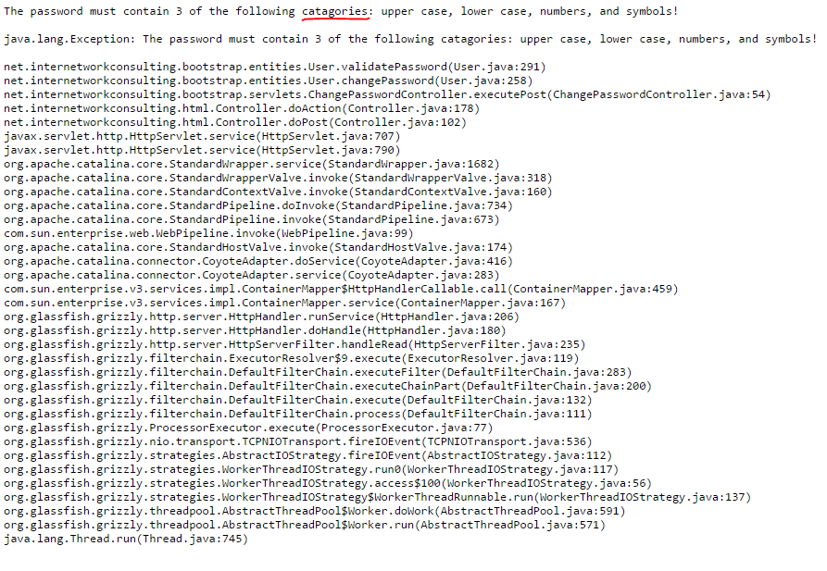
1.6 Group Edit
Upon Login in, click menu→ Click Groups→ Click “+”→Fill in appropriate fields→Click Save

1.6.1 Expected Results
The program creates the newly specified group with the appropriate members and name

1.6.2 Observed Results
User is given the message: “This need updated so that if a user is added to administrators group, we update the databases user to allow grants!” and the group is not created.

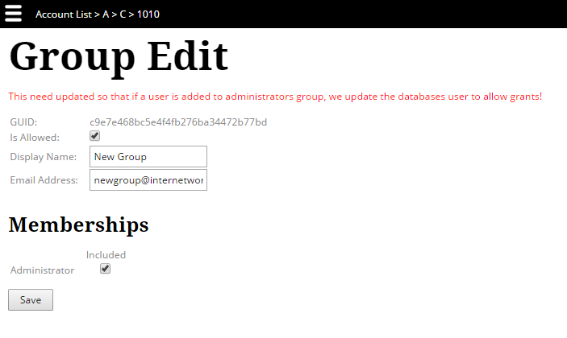
1.7 Add Securables
Upon Login in, click menu→ Click Securables→ Click “+”

1.7.1 Expected Results
Upon adding a new securable, the user should be taken to the Securable Edit screen

1.7.2 Observed Results
User is given the message: “The requested securable could not be found!”
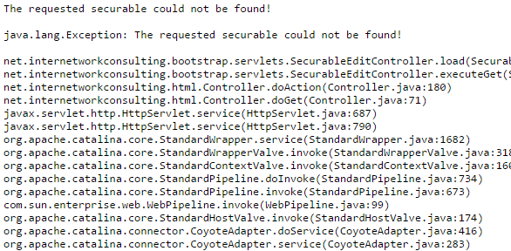

1.8 Delete Securables
(not a bug)
Upon Login in, click menu→ Click Securables→ Click “x”

1.8.1 Expected Results
This is not considered a bug due to not being able to delete foreign keys

1.8.2 Observed Results
User is given the message: “Cannot delete or update a parent row: a foreign key constraint fails ("incbootstrap"."permissions", CONSTRAINT "Securable<Permissions" FOREIGN KEY ("Securables GUID") REFERENCES "securables" ("GUID"))”
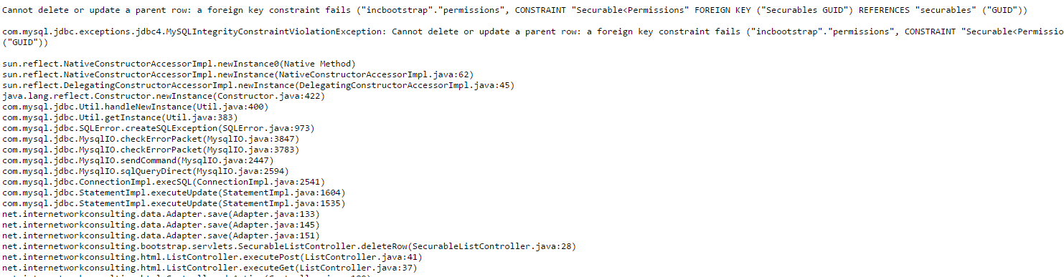

1.9 Computer Edit Save
Upon Login in, click menu→ Click Computers→ Click “+”→Leave fields blank→Click Save

1.9.1 Expected Results
On creating an empty computer, User is given the message: “Please fill in specified fields!”

1.9.2 Observed Results
Currently blank computers can be created by the user.

1.10 Computer Edit Save Type
Upon Login in, click menu→ Click Computers→ Click “+”→Create a duplicate entry→Click Save

1.10.1 Expected Results
If the user creates a duplicate computer, the message should read, “Message: Duplicate entry for key 'MAC Address/Description'”

1.10.2 Observed Results
On creating a duplicate, there is a typo in the error message that reads, “Message: Duplicate entry” for key 'MAC Address/Description'”

1.11 Setting Edit Save
Upon Login in, click menu→ Click Settings→ Click “+”→Leave fields blank/Create a duplicate entry→Click Save

1.11.1 Expected Results
If fields are blank, message: “Please fill in specified fields!”
If duplicate setting is created, message: “This setting already exists!”

1.11.2 Observed Results
Currently the user is able to create both duplicate and empty settings.

1.12 Report List Delete
(not a bug)
Upon Login in, click menu→ Click Reports→ Click “x”

1.12.1 Expected Results
This is not considered a bug due to not being able to delete foreign keys

1.12.2 Observed Results
User is given the message: “Cannot delete or update a parent row: a foreign key constraint fails ("incbootstrap"."report blocks", CONSTRAINT "Blocks>Report" FOREIGN KEY ("Reports GUID") REFERENCES "reports" ("GUID"))”

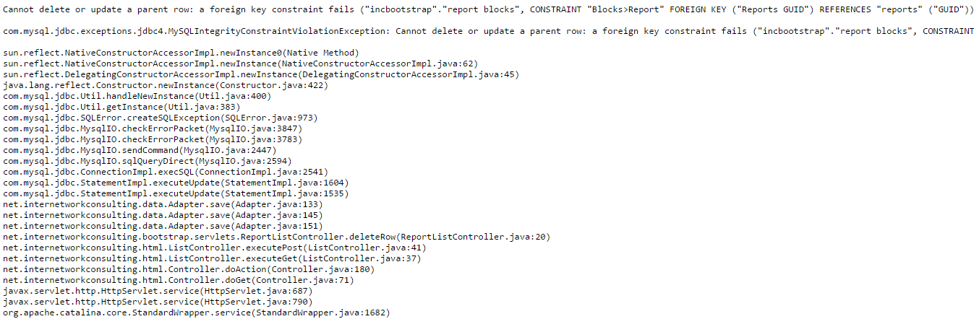
1.13 Report Edit Save
Upon Login in, click menu→ Click Reports→ Click “+”→ Leave fields blank→ Click Save→Click Menu→Click Report

1.13.1 Expected Results
On creating an empty report, User is given the message: “Please fill in specified fields!”

1.13.2 Observed Results
Currently blank reports can be created by the user.

1.14 Report Edit Save
Upon Login in, click menu→ Click Reports→ Click “+”→ Create a duplicate report→ Click Save→Click Menu→Click Report

1.14.1 Expected Results
If the user creates a duplicate computer, use should be given error message, and then be allowed to make changes to the current screen

1.14.2 Observed Results
On creating a duplicate, user is given an error message and then upon saving, is given another error message of “null” and report is not saved.
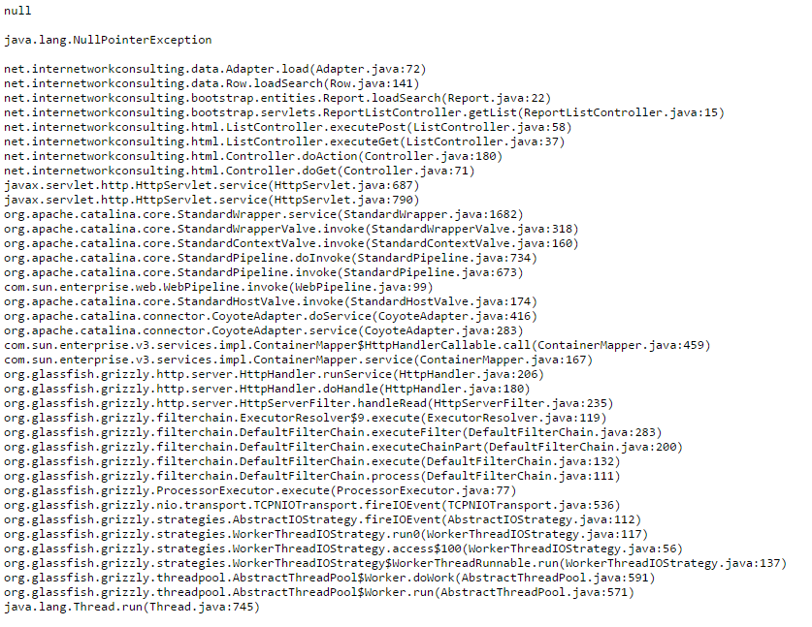

2 Design
This section will list the problem and the proposed change for each bug

2.1 Login
Launch Program and login with invalid credentials

2.1.1 Problem
Upon logging in with invalid credentials, the user is not given any message that his login credentials are incorrect

2.1.2 Proposed Changes
throw new exception(“Invalid Login Credentials”)

2.2 Edit Load

2.2.1 Problem
Upon the edit screen loading, the “Is Allowed” box is unchecked. On the user edit screen, the password date is empty and not showing the current date.

2.2.2 Proposed Changes
UserEditController Line 99: Add chkIsAllowed.setIsChecked(true);
UserEditController Line 124: Add dtPasswordDate.setDate.Now;
GroupEditController Line 99: Add chkIsAllowed.setIsChecked(true);
ComputerEditController Line 99: Add chkIsAllowed.setIsChecked(true);

2.3 User Edit Save

2.3.1 Problem
The user is currently able to create duplicate users and users that do not have a display name/SQL User.

2.3.2 Proposed Changes
Statement.Java: Change the Statement object that generates the SQL INSERT statement so that is explicitly creates the columns needs so that is does not use the defaults.

2.4 User Edit Save Sql User

2.4.1 Problem
The program is currently not creating the SQL user in the Database upon saving.

2.4.2 Proposed Changes
The SQL User is created upon clicking “Reset Password”. The same function that is used in to create the SQL user needs to also be implemented upon clicking “Save”

2.5 Change Password

2.5.1 Problem
“Categories” is spelled incorrectly
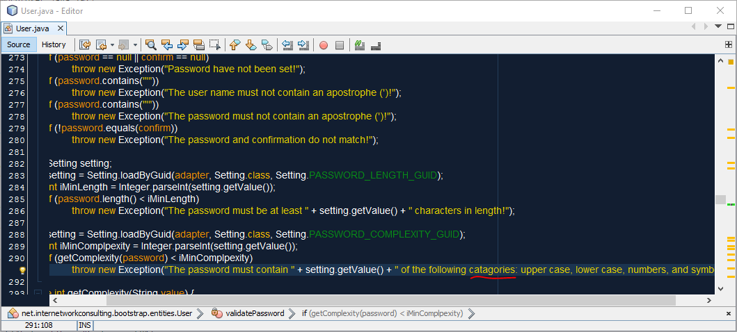

2.5.2 Proposed Changes
Line 291: Change “catagories” to “categories”

2.6 Group Edit

2.6.1 Problem
User is given the message: “This need updated so that if a user is added to administrators group, we update the databases user to allow grants!” and the group is not created.

2.6.2 Proposed Changes
GroupEditController Line 121: Implement the save group function by un-commenting the line
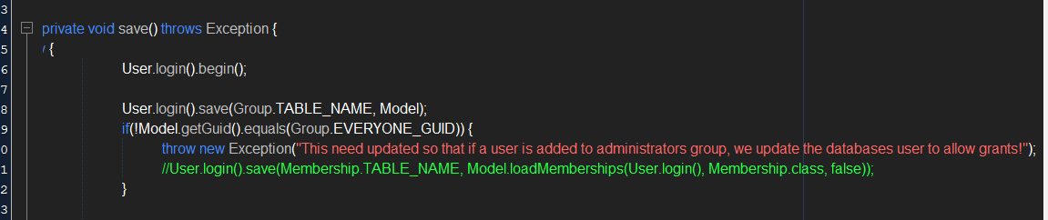

2.7 Add Securables

2.7.1 Problem
The user is not taken to the “Edit Securable” page

2.7.2 Proposed Changes
SecurableEditController Line 55: Add Model = new Securable();
Model.initialize();
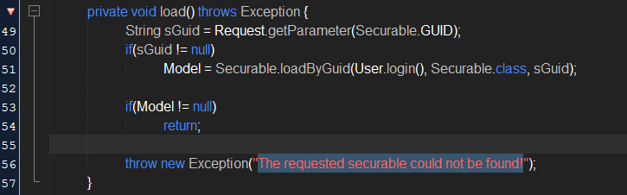

2.8 Computer Edit Save

2.8.1 Problem
Currently blank computers can be created by the user.

2.8.2 Proposed Changes
Statement.Java: Change the Statement object that generates the SQL INSERT statement so that is explicitly creates the columns needs so that is does not use the defaults.

2.9 Computer Edit Save Type

2.9.1 Problem
On creating a duplicate, there is a typo in the error message that reads, “Message: Duplicate entry” for key 'MAC Address/Description'”

2.9.2 Proposed Changes
Statement.Java: Change the Statement object that generates the SQL INSERT statement so that is explicitly creates the columns needs so that is does not use the defaults.

2.10 Setting Edit Save

2.10.1 Problem
Currently the user is able to create both duplicate and empty settings.

2.10.2 Proposed Changes
Statement.Java: Change the Statement object that generates the SQL INSERT statement so that is explicitly creates the columns needs so that is does not use the defaults.

2.11 Report Edit Save

2.11.1 Problem
Currently blank reports can be created by the user.

2.11.2 Proposed Changes
Statement.Java: Change the Statement object that generates the SQL INSERT statement so that is explicitly creates the columns needs so that is does not use the defaults.

2.12 Report Edit Save

2.12.1 Problem
On creating a duplicate, user is given an error message and then upon saving, is given another error message of “null” and report is not saved.

2.12.2 Proposed Changes
ReportEditController: Add a Try/Catch statement that will prevent the program from stopping

